**Contagious Ecthyma in Sheep and Goats**

**(Orf, Contagious Pustular Dermatitis, Sore Mouth)**

**Definition:**

* Contagious ecthyma is a viral, pustular dermatitis of young sheep and goats. Lesions usually involve the lips but can involve other cutaneous junctions such as the coronet, and can extend onto the face and ears as well.

**Etiology and Epidemiology**

* The parapoxvirus that causes contagious ecthyma is related to the viruses that cause [pseudocowpox](https://www.msdvetmanual.com/integumentary-system/pox-diseases/pseudocowpox-in-cattle" \o "Pseudocowpox in Cattle) and [bovine papular stomatitis](https://www.msdvetmanual.com/integumentary-system/pox-diseases/bovine-papular-stomatitis).
* The virus is transmitted by contact. It is highly resistant to desiccation in the environment and has been recovered from dried crusts after 12 years. In the laboratory, it is also resistant to glycerol and to ether.
* Contagious ecthyma is found worldwide and is common in young lambs reared artificially and in older lambs during late summer, fall, and winter on pasture, and during winter in feedlots.

**Clinical Findings and Diagnosis of Contagious Ecthyma in Sheep and Goats**

* Clinical evaluation
* Laboratory confirmation

**Contagious ecthyma, goat**

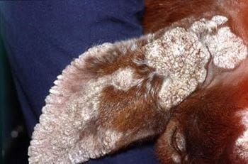

COURTESY OF DR. ROBERT DUNSTAN.

**Proliferative contagious ecthyma (orf), sheep**

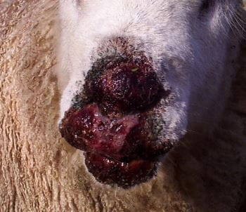

COURTESY OF DR. PHILIP SCOTT.

**Contagious ecthyma (Orf), sheep**

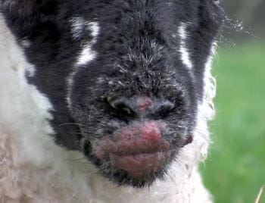

COURTESY OF DR. PHILIP SCOTT.

**Orf, lamb**

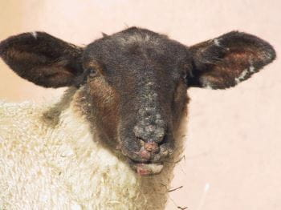

COURTESY OF DR. PHILIP SCOTT.

**Orf, lip crusts, lamb**

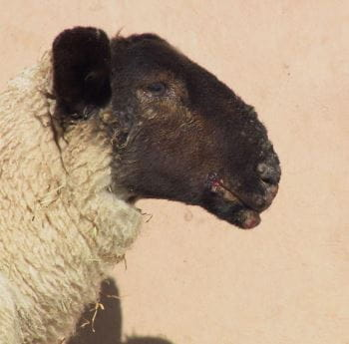

COURTESY OF DR. PHILIP SCOTT.

**Strawberry footrot, goat**

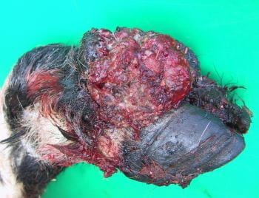

COURTESY OF DR. PHILIP SCOTT.

* The primary lesion of contagious ecthyma develops at the mucocutaneous junction of the lips and around erupting incisor teeth, and it may extend to the mucosa of the buccal cavity. Occasionally, lesions are found on the feet and around the coronet, where secondary bacterial infection with *Dermatophilus congolensis* commonly leads to strawberry foot rot.
* Ewes nursing infected lambs may develop lesions on the teats that extend onto the udder skin.
* The lesions develop as papules and progress through vesicular and pustular stages before encrusting.
* Coalescence of numerous discrete lesions often leads to the formation of large scabs, and the proliferation of dermal tissue produces a verrucose mass under them.
* When the lesion extends to the oral mucosa, secondary [necrobacillosis](https://www.msdvetmanual.com/respiratory-system/infectious-respiratory-system-diseases-in-cattle/necrotic-laryngitis-in-cattle) frequently develops.
* During the course of the disease (1–4 weeks), the scabs drop off and the tissues heal without scarring.
* During active stages of infection, more severely affected lambs do not eat normally, and they lose condition.
* Extensive lesions on the feet result in lameness.
* Mastitis, sometimes gangrenous, may occur in ewes with lesions on the teats.
* The ecthyma lesion is characteristic.
* The disease must be differentiated from ulcerative dermatosis, which produces tissue destruction and crateriform ulcers.
* Compared to ulcerative dermatosis, ecthyma usually affects younger animals; however, this criterion can be used only presumptively.
* [Foot-and-mouth disease](https://www.msdvetmanual.com/generalized-conditions/foot-and-mouth-disease) and [bluetongue](https://www.msdvetmanual.com/generalized-conditions/bluetongue) infection should also be considered as differential diagnoses if morbidity is high and the clinical signs include salivation, lameness, and fever. Staphyloccocal folliculitis affects the skin of the muzzle and surrounding the eyes.

**Treatment and Control :**

* Secondary infection
* Live vaccines
* Both parenteral and topical antimicrobials may help combat secondary bacterial infection of the skin lesions of contagious ecthyma.
* In endemic areas, appropriate repellents and larvicides should be applied to the lesions to prevent myiasis.
* The virus is transmissible to humans; lesions in humans are usually confined to the hands and face, are more proliferative, and can be very distressing.
* Veterinarians and sheep handlers should exercise reasonable protective precautions and wear disposable gloves.
* Most cases in humans are misdiagnosed and mistaken for other diseases (eg, anthrax) which often leads to unnecessary treatment with antibiotics or cryosurgery.